SLAM

Simultaneous Localization and Mapping (SLAM) is the name that defines the robotic problem of building a map of an unknown environment while simoultaneously keeping track of the robot's location in the map that is being built.

As you may already know, in ROS Navigation you use the slam_gmapping package in order to solve this problem. The slam_gmapping package is based on the OpenSLAM implementation, which uses a laser scanner in order to build a 2D map of the environment, and a particle filter in order to be able to localize the robot in the environment.

____________________________________________________________________

The next chapter will discuss how all these components, sensors and actuators, interact with each other with the help of ROS for SLAM implementation. Further, we will discuss each SLAM algorithm in detail.

As the robot continues to explore and scan it’s environment, the SLAM algorithm uses odometry data to estimate the robot’s current position within the map. This estimation is compared to readings of the environment, obtained from sensors, and to facilitate corrections if these reading are proved inaccurate. The process is continued until a complete map of the environment is created. A basic LiDAR based SLAM algorithm can be divided into five main parts: landmark extraction, data association, state estimation, state update, and landmark update [RB04]. A description of this process is visually represented in Fig. 4.1. In this chapter we will discuss in brief five SLAM algorithms namely GMapping, Hector SLAM, RTAB-MAP, RGB-D SLAM, and VINS Mono of which the latter three are camerabased visual SLAM algorithms.

1) LiDAR based SLAM

1.1 Gmapping

OpenSLAM’s Gmapping is the most used LiDAR based SLAM algorithm which follows an efficient implementation of Rao-Blackwellized Particle Filter (RBPF) [Gri05] and [Gri07]. Each particle is a sample of history of robot poses and posterior over maps given the sample pose history, i.e., each particle carries an individual map of the environment based on the recent observations. The primary objective is to reduce the number of particles for which an adaptive technique is implemented. Instead of completely relying on the movement of the robot (history of robot poses), recent observations are used to correct the generated map.

Previously, [Mur00] compared two algorithms viz., online EM (Expectation-Maximization) and Bayesian inference. In the online EM, the map was considered to be a fixed parameter whereas, in the Bayesian inference, the map was considered as a matrix of random variables. It was shown that the online EM algorithm gets easily stuck in a local minima, which causes the robot to be considered as lost. On the other hand, Bayesian inference, where multiple hypotheses are maintained, proved to be more robust, and a Rao-Blackwellized particle filter method is introduced to approximate the map. [Gri05] continue the work on the same to make the approximation even faster by reducing the number of particle and keeping accuracy intact. The Algorithm is summarized as follows in [Gri07]:

1. x 0(i) t = x (i) t −1 ⊕ ut −1 is the initial guess of the robot’s pose represented by the particle i. This is calculated from the previous pose x (i) t −1 of that particle and the odometry measurements ut −1 collected since the last filter update. Here, the operator ⊕ is the standard pose compounding operator

2. Starting from the initial guess x 0(i) t , a scan-matching algorithm is executed based on the map m (i) t 1 . The search is bounded to a limited region around x 0(i) t . In case an failure is reported, the pose and the weights are calculated using the motion model and steps 3 and 4 are ignored.

3. In an interval around the pose xˆ (i) t reported by the scan-matcher, a set of sampling points is selected. Based on these points, the mean and the covariance matrix of the proposal are calculated by evaluating the target distribution p(zt m (i) t 1 , xj )p(xj x (i) t 1 ,ut 1 ) in the sampled positions xj . During this phase, the weighting factor η (i) is calculated.

4. The Gaussian approximation N (µ (i) t ,Σ (i) t ) of the improved proposal distribution is calculated and the new pose x (i) t of the particle i is drawn.

5. The importance weights are updated.

6. According to the drawn pose x (i) t and the observation zt , the map m(i) of particle i is updated .

This SLAM algorithm is available as a black-box package in the ROS environment. The algorithm is tested with and without the provision of odometry. The setup and results of testing are provided in the next chapter.

1.2 Hector SLAM

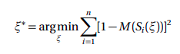
Hector SLAM is LiDAR based 2D mapping and pose estimation technique available as an open source implementation as proposed in [Koh11]. Unlike Gmapping, Hector SLAM is not based on Rao-Blackwellized Particle filter for mapping and localization and further, it does not require wheel odometry information. Hector SLAM uses a Guass-Newton approach for the scan matching as proposed in [LK81]. The 2D pose is estimated using the scan matching process alone. The algorithm tries to find an optimum alignment of the laser scan’s endpoints with the already constructed map by finding the rigid-body transformation ξ ∗ = (px ,py ,ψ) T and minimize

where, the function M (Si (ξ)) is the map value at Si (ξ) i.e. the world coordinate of the endpoint of the laser scan. Given a prior estimate of ξ, the step transformation ∆ξ is estimated by optimizing the error such that
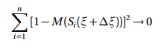

Fig. 4.2 provides an overview of the Hector algorithm stack. The preprocessed data from the LiDAR is forwarded to a scan matching algorithm which in this case follows a GaussNewton approach to optimize the alignment using eq. 4.1. The Hector SLAM is also capable of 6 DOF (Degrees Of Freedom) pose (Attitude) estimation using an Extended Kalman Filter, since it was initially designed for search and rescue UGVs. In this thesis we only deal with 2D pose estimation and mapping.
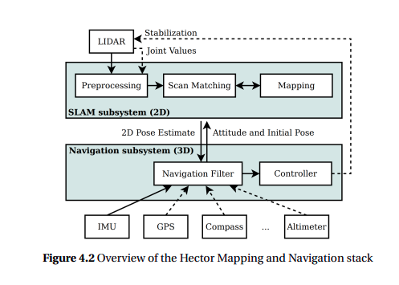

2) Visual SLAM

2.1 RTAB MAP

RTAB-Map (or Real-Time Appearance-Based Mapping) is an RGB-D, Stereo and Lidar Graph-Based SLAM approach [LM19]. This approach is based on an incremental appearance-based loop closure detector which uses a bag-of-words approach and tries to estimate the likelihood that a new image comes from a previous location or a new location. Whenever a loop closure hypothesis is accepted, a new constraint is added to the map’s graph, which is the map insertion step in a basic SLAM algorithm, as explained in detail at beginning of this chapter. A graph optimizer tries to minimize the errors in the map. RTAB-MAP also accommodates a memory management approach [LM11] which is used to limit the number of locations used for the loop closure and graph optimization. This helps make the algorithm run faster on less powerful machines respecting the real-time constraints.

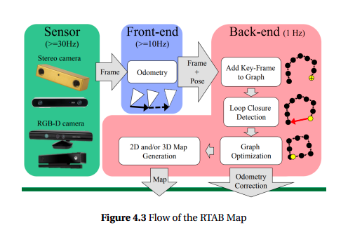

2.2 RGB-D SLAM

RGB-D SLAM uses both color (RGB) and depth images to produce map. The map generation and optimization follows four basic steps. First, visual features like SURF, SIFT, and ORB [Kar17] are extracted from the color image. Then these features are compared (or matched) with the features from previous frames. The location of the features in the color image is mapped to the corresponding location in depth image which gives a set of point-wise 3D correspondences between any two frames. The pose of the camera is obtained by evaluating these correspondences to get a relative transformation between the current and the previous frame using RANSAC [Hu12]. The Fig. 4.4 shows a flowchart for the process.

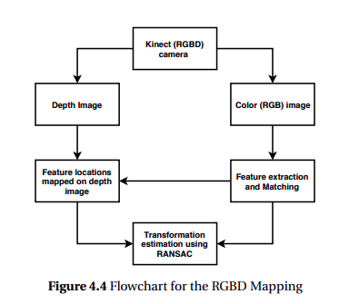

2.3 VINS-MONO

VINS-Mono (or Visual Inertial Navigation System - Monocular) SLAM algorithm is based on Visual Inertial Odometry. Visual-inertial odometry (VIO) is extensively applied to state estimation problems in a variety of domains, e.g., autonomous vehicles, virtual and augmented reality, and UAVs. The research has reached a level of maturity that many commercial products now use proprietary VIO algorithms. Additionally, there are many open-source software packages available which provide off-the-shelf visual pipelines deployable on an end-user’s system.

A simple yet efficient way to deal with visual and inertial measurements is a looselycoupled sensor fusion [Wei12], [Lyn13], where data from IMU is treated as an independent module to assist pose estimation based on visual structure from motion. An Extended Kalman Filter is employed, where IMU is used for state propagation and the vision-only pose is used for the update. Further, tightly-coupled visual-inertial algorithms are either based on the EKF [LM13] or graph optimization [She15], where camera and IMU measurements are jointly optimized from the raw measurement level.

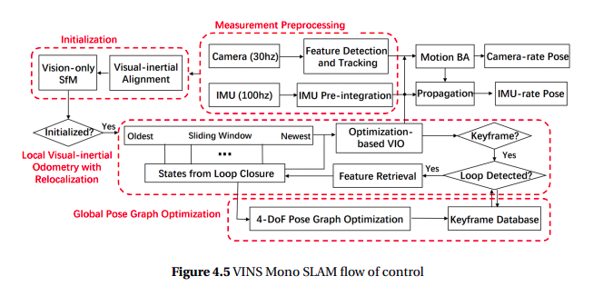

VINS-Mono is a non-linear optimization-based sliding window estimator which tracks robust corner features [ST93]. Additionally, VINS-Mono introduces several new features to this class of visual-only pose estimation framework. The acceleration and orientation data from IMU is pre-integrated before being used in the optimization, and a tightlycoupled procedure for relocalization is implemented. VINS-Mono additionally features modules to perform 4DoF pose graph optimization and loop closure since it was originally designed for UAVs. An overview of the VINS-mono architecture is shown in the Fig. 4.5.

Following chapter discusses the experiments, and results for each of these SLAM algorithms.

In order to create accurate representation of the environment one requires accurate pose estimates. To create accurate pose estimates, however, one requires an accurate map. In robotics this is regarded as the SLAM (Simultaneous Localization And Mapping) or CML (concurrent mapping and localization) problem. Multiple solutions have been proposed, developed and honed for SLAM treated as a three dimensional problem that considers a vehicle capable of movement in a plane and a corresponding two dimensional map.

SLAM is not a robotics exclusive problem, quite the contrary, it is a general problem that can be applied to a variety of objects moving in a variety of environments and making use of a variety of techniques to acquire data. Some of the most exotic examples include the proposal to use SLAM techniques to aid minimally invasive surgery by mapping the surgery scene inside the human body by making use of available imaging data as described by P. Mountney et al in [26], as well as the so called FootSLAM [1]. FootSLAM uses foot-mounted inertial sensors to provide odometry data and exploits human perception and cognition to achieve infrastructure less localization in a previously unknown environment.

Although pretty much any sensory input coupled with anything that moves could be used as a basis for SLAM, for the purposes of this work the main focus further will be on robotic vehicles using LIDAR data for mapping and localization.

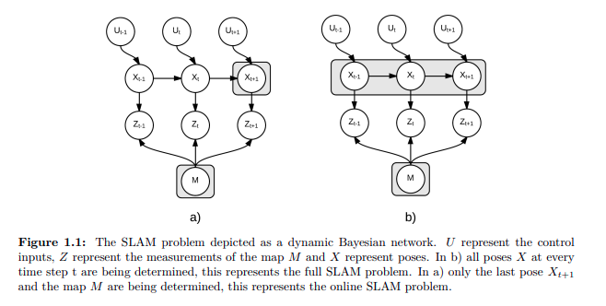

Simultaneous localization and mapping, mostly known by its acronym SLAM, refers to the problem of creating and updating a map of an area, while simulatneously determining the location of the device at work within said map. Finding a solution to this problem is considered necessary for a mobile robot to be truly autonomous. It has been formulated and solved as a theoretical one in a number of different forms, and has been implemented in a number of diferent domains – including indoor robots and outdoors, underwater and airborne systems. Substantial issues remain, however, in realizing a general SLAM solution and in building and using perceptually rich maps as part of a SLAM algorithm.

Consider a mobile robot moving through a static, unknown environment. If the pose of th robot is known with certainty using for example GPS, we have a straightforward mapping problem. Vice versa, if the robot with certainty knows the positions of objects in its environment, we have a localization problem. In such situations, Monte Carlo Localization could be a fitting algorithm for generating position estimates. However, when both the pose and the map are unknown, motion noise corrupts the pose estimates, which in turn corrupts perceived locations of objects in the world (landmarks) along with sensor measurement noise. In other words; error in the robot’s pose correlates errors in the map, and thus map and robot pose must be estimated simultaneously.

SLAM has many applications in modern robotics. As mentioned, the technology can be utilized in situations where other forms of position estimation techniques are unavailable or inaccurate, such as operations indoor, sub sea underground or on the surface of other planets. SLAM can also be used for the purpose of providing maps itself. Examples are during urban search and rescue (USAR) situations and in- and outdoor environment surveying. Mobile robots utilizing SLAM are in fact becoming a common household article, vacuum cleaners as iRobots Roomba.

1) Map Representations

Several map representations are recognized as suited for SLAM purposes, and literature broadly divides them into metric and topological map representations.
1.1 Metric map representations

Metric maps capture the geometric properties of the environment, and among them occupancy grid maps and landmark-based maps are considered.

Occupancy Grid MAPS

Occupancy grid maps are discrete cell maps which may contain 2D,2.5D or 3D information. They are advantageously very visually comprehensible to human eyes, as they resemble actual regular maps, or floor-plans in particular (in 2D especially).

The grid cells can be thought of as pixels in an image. Each cell has a predefined location corresponding to a real-world location and a predefined size, where the latter corresponds to the resolution of the grid map. Within the cells we find information regarding the probability that the corresponding real-world location contains free or occupied space. The information can be expressed as an estimated log-odds, binary variable, or a tree structure determining whether the cell is occupied or not.

In addition, the grid maps being easy to interpret by humans, the map representation is advantageous when performing automatic path planning. A third advantage is the fact that the grid maps can be created for practically any resolution, allowing for maps with the level of detail appropriate to the application and its requirements.

A possible disadvantage of occupancy grid maps are the large amount of memory they can require. Operating a large number of sizable maps with high accuracy can require significant amount of memory, even in modern computers. As mobile robots often have limited size and therefore smaller computers, this might require some trade-off.

Landmark-based Maps

Landmark-based maps identify and maintain the location of certain features in the environment. These may be corners, line segments or points – and are called landmarks.

A great advantage with landmark-based representation versus grid maps, is the compactness of the model. As only feature points isolated from the structure of the environment are considered as landmarks, memory resources and computational costs are minimized. This is clear if one interprets grid map versions to treat every occupied cell as a landmark. Because of this, landmark-based maps are well suited for managing more than one version of the map at the time, allowing for multi-hypothesis tracking.

On the other hand, due to the foregoing, the map representation is not suited for automatic obstacle avoiding and path planning. This is because, contrary to that in occupancy grid maps, the lack of a landmark does not equal a free, unoccupied space.

What makes SLAM using landmark-based maps difficult, is the problem of data association. Data association concerns recognizing observed landmarks correctly – that is, either the correct previously observed landmark, a new landmark or not a landmark at all. Errors on the data association can lead to catastrophic consequences in that the SLAM method fails. When choosing landmarks, gives a shortlist for which candidates to appoint as landmark:

- Landmarks should be easily re-observable, meaning they should be detectable from different positions and different angles.

- Individual landmarks should be unique enough so that they are distinguishable from each other.

- Landmarks should be plentiful in the environment, so that the robot is in no risk to spend extended time without any visible, and thus may get lost.

- Landmarks should be stationary. If not, the robots relative location to the landmark is useless.

1.2 Topological map representations

Topological maps represent the environment as a list of significant places that are connected by arches – in other words, a graph. Such a representation of the world simplifies the problem of mapping large extensions, but the lack of metric information makes it unfit for guiding an autonomous vehicle. Both these and landmark-based map representations are, however, excellent if the main purpose is accurate localization rather than mapping or both.

2) Possible sensors

A wide range of sensors can be used for SLAM purposes, and different sensors are used in different contexts. A wheeled indoors robot would not use the same means as an unmanned aerial vehicle (UAV) or an autonomous underwater vehicle (AUV). As a USV with lidar, IMU and GNSS is used in the scope of this thesis, this context is given the most focus, although some other relevant possibilities are presented as well – in consideration with the application at hand.

Sensors broadly fit into two main categories: exteroceptive sensors and interoceptive sensor. The former looks “outside” the robot generate absolute position measurements, while the latter looks “inside” the robot to measure relative position.

2.1 Exteroceptive Sensors

Exteroceptve sensors look “outside” the robot to generate absolute position measurements.

Range Finders

Range finders tell the distance to the nearest object in the nearest direction or sector. Examples are sonar, radar and lidar based systems.

Not taking cameras into account, sonars, or ultrasonic sensors are generally the cheapest source of spatial sensing for mobile robots. They are particularly for underwater purposes, though simply for the reason that other sensors such as cameras or lidar/radar struggle there. The low frequency sound waves of sonars minimizes absorption, which makes the resolution better in sub sea applications. Ultrasonic sensors are also popular in indoors robotics, where distances are small.

The RADAR system and the LiDAR system work much in the same way, with the only difference being the use of radio waves in the former, versus light in the latter. They emit rapid radio or laser signals, the signals bounce off obstacles and returns. By calculating the time of flight (ToF), the distance to the objects can be estimated with high accuracy.

Both LiDAR and RADAR systems are compatible with autonomous vehicles. The fact that the autonomous Tesla car relies on RADAR as the primary sensor, and Google, Uber and Toyotas versions rely on their light emitting rival, substantiates that statement. Some differences in service delivered and price do, however, exists.

First of all, RADR systems are relatively less expensive tan LiDAR systems, although the difference was much larger a few years ago. The former also works equally well in all weather conditions,whereas the performance of LiDARs starts to dwindle in the snow, fog, rain and dusty weather conditions. As RADAR systems can utilize the Doppler frequency shift to accurately determine relative traffic speed, it would seem that this would be the better choice. However, what might make LIDAR sensors a more popular for SLAM purposes, is the fact that high-end ones can identify the details of a few centimeters at more than 100 meters. This is advantageous for landmark extraction in particular.

LIDAR sensors come with a range of different specifications. Price will obviously be an important question, as well as the dimension of the sensor workspace (2D or 2.5D). Other important metrics when choosing a LIDAR system are horizontal and vertical Filed of View (FoV), horizontal and vertical resolution and he time it takes for the LIDAR to complete one revolution. One LIDAR revolution is hereby called scan.

Vision Sensors

These sensors mainly come in three types: monocular cameras, stereo cameras and RGB-D cameras. Contrary to LIDARs, the sensory data of tho former do not contain range data. The information is however achievable at the price of some computational cost. Although RGB-D directly compute the depth in the images, their sensitivity to illumination makes them unfit to receive direct sunlight. As the dark of night would likely cause important information to be imperceptible to the cameras, it is unclear how well suited these are as the main exteroceptive sensor for a SLAM system on an autonomous ferry. Infrared cameras would definitely be needed.

Vision sensors are however advantageous over range finders in the rich visual information available in the images. This allows for sparse key-point extraction using appropriate feature extraction methods. These key-points are more distinctive than geometric structures such as corners and edges, making them less susceptible for data associati. Variations of the method are many, but the basic idea is to iteratively refine the relative pose of two ovron errors.

Working with images also allows for treating landmarks as a classification problem using deep learning. A set of landmarks of known geometry characteristics and sizes could be used to train networks such as, versions of R-CNN or SSD to classify landmarks, and then compare image with the real sizes. Furthermore, it has been shown that deep neural networks can be trained to find the relative pose between two images, directly from the image pair.

2. Proprioceptive Sensors

Proprioceptive sensors measure values internal to the system to generate relative position. Wheel odometry in the form of encoders or hall sensors are popular with wheeled robots, as they give a pretty accurate estimate on distance traveled.

IMUs however, are, and can be used to get an odometric estimate. They consist of a gyroscope and an accelerometer measuring angular velocity and linear acceleration, respectively. Integrating these data give the required angles, velocities and position estimates. However, the estimates are error prone. For this reason, a solution based on dead reckoning will drift, and the estimate are best to give starting points for scan algorithms, or fused with other sensor data i.e. GPS pose estimate or SLAM pose estimate.

Note:

SLAM has been implemented using several other means of sensing as well. For example, it can use tactile sensors. That is, the robot senses the environment through touch only. Other exmples are using range measurements from radio beacons, and measuring strength of WIFI-signals from access points in the vicinity.

3) Feature ans Scan Matching

As mentioned on visual sensors, matching features in two successive images can give a good estimation of the relative pose between them. The features can be extracted using methods like the Harris Corner Detector, Scale Invariant Feature Transform (SIFT) or Speeded Up Robust Features (SURF).

Likewise, examples of feature extracting algorithms for laser scanners like LIDARs are Spike Landmark extraction and Random Sampling Consensus (RANSAC). Spikes are extreme value differences in the distance to a location measured from different angles. This indicates a geometric change between the angles, and the location can be interpreted as a landmark. The landmarks are found by taking a random sample of the laser readings and do a least squares approximation to find the best fit line running between them.

3.1 Scan Matching

Scan matching is a concept frequently used in SLAM algorithms, and some solely rely on it. He concept is combining range measurements from one scan to the next. The result can be used to estimate the transformation between them. I the matching done with an existing map, new scans are implicitly matched with all preceding scans.

There exist numerous ways to perform scan matching, with Iterative Closest Point (ICP), Polar Scan Matching (PSM) and Normal Distribution Transform (NDT) seemingly being one of the most popular ones.

ICP is originally a general approach for registering 3D point clouds, an approach with which work on scan matching based localization stated in 1992. Variations of the method are many, but the basic idea is to iteratively refine the relative pose of two overlapping scans by minimizing the sum of squared distances between the corresponding points in the two scans. By thresholding distances between matched scans and their change in orientation, the method seeks to eliminate false matches. Using Nearest Neighbor methods, ICP’s search for point correspondences is, however, expensive.

PSM exploits the natural polar form of the scans, making search for corresponding points less computationally demanding. However, the method prepossesses both the current and the reference scan in order to remove objects likely to move. Still, shows that the PSM approach can be faster than ICP, and shows its application to the SLAM problem through a Kalman Filter implementation.

NDT models the distribution of all reconstructed 2D-points of one scan by a collection of local normal distribution. In order to estimate a geometric transform relating to the new scan, a measure is defined by mapping all points according to the transform. The corresponding local normal distribution are then evaluated, and the sum of them are maximized through a Newton’s method optimization. The main idea with the transform is that by matching piece-wise continuous and differentiable probability densities, no explicit correspondences have to be established. NDT is successfully applied to the SLAM problem in mid-size indoor environments can be modeled good enough by local normal distributions, as well.

4) EKF-SLAM

KF have numerous applications in technology, and is commonly implemented in navigation and control for vehicles, but also in fields such as signal processing and econometrics. Concisely summarized, the KF is an algorithm using a series of measurements containing statistical noise other inaccuracies over time, and produces estimates of unknown variables by estimating an assumed Gaussian-linear joint probability distribution over them for each time frame.

The use of an EKF to solve SLAM problem (EKF-SLAM) was first introduced in an article from 1986. This approach models the mtion and observations as state space models with additive gaussian noise, uses a high dimensional EKF to provide a posterior over a map and the robot pose. A detailed description of EKF slam can be found in [8].

As EKFs linearizes non-linear models about the most likely states, convergence and consistency can only be guaranteed in the linear case. This approximation is however good if the true models are approximately linear and if the time step is sufficiently small.

In 2D space, the map is typically implemented as a set of landmarks, with a representation of two states in the EKF for each landmark. Adding the three states representing the robot pose, we have a 2N + 3 dimensional state-space for N landmarks. Thus, as the map grows large, the complexity of the EKF representation grows quadratically both in memory and computational time. This is because the joint covariance matrix must be updated at every observation in order to maintain the correlations between all state variables.

5) Particles Filters and Rao-Blackwellization

Like KF, particle filters represent algorithms for estimating state probability distributions. The representation of these probability distributions, however, differ. While KFs represent them using multivariate Gaussians, Particle filters use particles. These particles can be thought of as samples of an unknown posterior distribution.

In its simplest form, the particle filter is a two-step algorithm. As a measurement is made, the current set of particles are given an importance weight based on how well they coincide with said measurement. This way, areas of high probability contain more particles than areas of low probability. This is achieved through the following resampling step, where a new set of particles is arbitrary chosen. The new particles are chosen with a probability proportional to their assigned importance weight.

Using enough particles, the particle filter can approximate arbitrarily complex and multi-modal probability distributions. The Monte Carlo localization approach (MCL) takes advantage of this, and is a fast, accurate and memory-intensive global localization method in which the environment is known.

I their narrative form, particle filters scale badly in the number of dimensions, as the number of particles needed grows exponentially in the number of dimensions of the estimation. Further, as a solution to the SLAM problem, a particle filter would consider each particle as a position and a map linked to it, leading to sampling over all possible maps and positions.

However, the fact that because of the conditional dependencies of the SLAM problem, correlations between elements of the map only arise through pose uncertainty. This makes it possible to estimate landmarks independently, and a particle filter can factorize the SLAM posterior into:

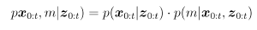

where x denotes the set robot poses, or the trajectory if you will, m denotes the map and z denotes the set of observations made. The first factor can be thought of as the path posterior, and the second, the map posterior.

Introduced in 2002, FastSLAM utilizes this factorization. FastSLAM calls it Rao-Blackwellization, because it is an instance of the Rao-Blackwellized particle filter. Contrary to EKF-SLAM with its one marge covariance matrix, FastSLAM keeps an EKF of each landmark, in each particle. At the same time, the scheme can boast of logarithmic complexity.

One other advantage with FastSLAM, is the natural multi-hypothesis data association. The data associations are done per particle, and if things are working as intended, particles with the correct information get higher importance weight, while others tend to die in the filter.

FastSLAM has shown capabilities of creating an accurate map, and an example run on the popular Victoria Park data-set can be seen in. Although the algorithm originally is landmark-based, it can be modified to use grid-maps.

6) Loop-Closure

Loop-closure detection is crucial for enhancing for robustness of both topological and metrical SLAM algorithms. The loop closure problem consists of detecting when the robot has returned to a previously visited location after having discovered new terrain, and recognizing which part of the constructed map it represents. Of all sub-problems in SLAM, this is considered a harder one.

Loop closure can be handled explicitly by correcting backwards in time. Some SLAM algorithms deal with the problem implicitly through built-in mechanisms. Other algorithms do not take the problem into account, and relies on them being accurate enough to avoid it.

When a SLAM algorithm fails to handle loop closure, the same physical location is represented at two or more different locations in the map. This leads to map inconsistencies which can e.g. be seen as double walls. Such map inconsistencies cause problems for path planning, although the robot pose estimate might still be sufficient.

7) Graph-SLAM

A key disadvantage of filter techniques is that data is discarded after processing. This removes the possibility of revisiting relevant data while building the map, in case corrections are in order. GraphSLAM seeks to avoid this issue by exploiting that the posterior of the full SLAM problem naturally forms a sparse graph. The graph leads to a sum of nonlinear constraints, which when optimized yields a maximum likelihood map with a set of corresponding robot poses.

The edges in the graph can be thought of as motion edges and measurement edges, where the former links to poses and the latter a pose to an observed map feature. The edges all correspond to a nonlinear constraint, named as information constraints. These information constraints sum up to a nonlinear least squares problem. The GraphSLAM scheme linearizes this set of nonlinear constraints, resulting in a sparse information matrix and an information vector. The matrix is then reduced using variable elimination techniques, which lowers the dimensionality of the optimization problem, defined only over robot poses. The path posterior map is then recovered using standard inference techniques.
Bibliography

[8] “A solution to the simultaneous localization and map building (SLAM) problem”

